WINE QUALITY PREDICTION BY MACHINE LEARNING

INTERDISCIPLINARY PROJECT

Submitted in partial fulfillment of the requirements for the award of Bachelor of Engineering degree in Computer Science and Engineering

By

T .Jeevan Prasad
Reg. No–42110515


DEPARTMENT OF COMPUTER SCIENCE AND ENGINEERING

SCHOOL OF COMPUTING

SATHYABAMA

INSTITUTE OF SCIENCE AND TECHNOLOGY (DEEMED TO BE UNIVERSITY)
CATEGORY - 1 UNIVERSITY BY UGC
Accredited with Grade “A++” by NAAC I Approved by AICTE JEPPIAAR NAGAR, RAJIV GANDHI SALAI, CHENNAI - 600119

APRIL - 2025


DEPARTMENT OF COMPUTER SCIENCE AND ENGINEERING

BONAFIDE CERTIFICATE

This is to certify that this Interdisciplinary Project Report is the bonafide work of T.JEEVAN PRASAD (Reg.No:42110515) who carried out the Project entitled “WINE QUALITY PREDICTION BY MACHINE LEARNING” under my supervision from January 2025 to April 2025.

Internal Guide
DR. D.SARAVANAN, M.TECH., Ph.D.,

Head of the Department
Dr. L. LAKSHMANAN, M.E., Ph.D.

Submitted for Interdisciplinary Project Viva Voce Examination held on-----------------------

Internal Examiner External Examiner

DECLARATION

I, T.JEEVAN PRASAD (Reg. No–42110515), hereby declare that the Interdisciplinary Project Report entitled “Wine Quality Prediction” done by me under the guidance of
Dr.D.SARAVANAN, M.TECH., Ph.D., is submitted in partial fulfillment of the requirements for the award of Bachelor of Engineering degree in Computer Science and Engineering.

DATE:

PLACE: Chennai SIGNATURE OF THE CANDIDATE

ACKNOWLEDGEMENT

I am pleased to acknowledge my sincere thanks to the Board of Management of Sathyabama Institute of Science and Technology for their kind encouragement in doing this project and for completing it successfully. I am grateful to them.
I convey my thanks to Dr. T. Sasikala M.E., Ph. D, Dean, School of Computing, and Dr. L. Lakshmanan M.E., Ph.D., Head of the Department of Computer Science and Engineering for providing me necessary support and details at the right time during the progressive reviews.
I would like to express my sincere and deep sense of gratitude to my Project Guide DR. D.SARAVANAN, M.TECH., Ph.D. for his valuable guidance, suggestions, and constant encouragement paved the way for the successful completion of my project work.
I wish to express my thanks to all Teaching and Non-teaching staff members of the Department of Computer Science and Engineering who were helpful in many ways for the completion of the Interdisciplinary project

TRAINING CERTIFICATE

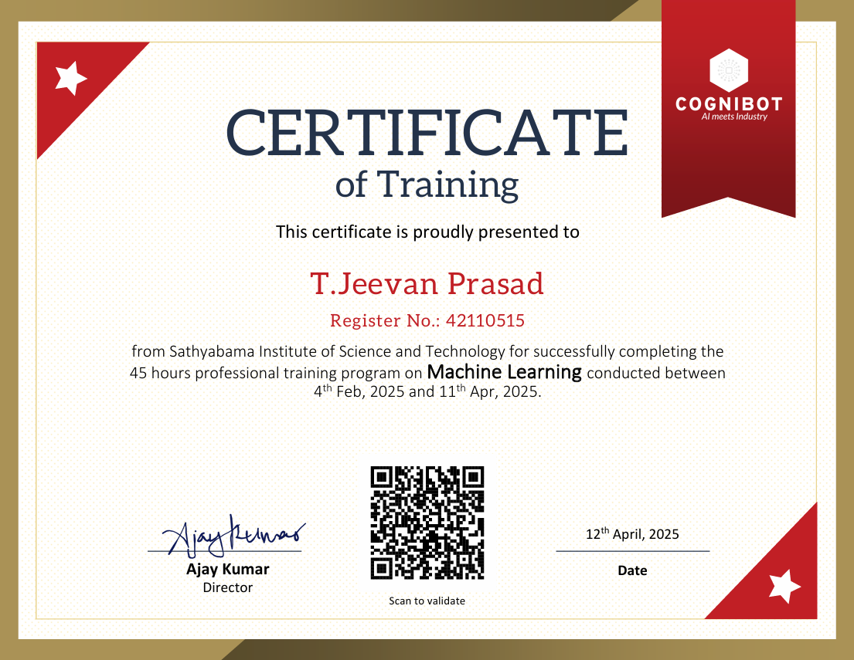

ABSTRACT

This project presents a machine learning-based approach for predicting the quality of wine using the Decision Tree Classifier algorithm. The model is trained on the UCI Wine Quality dataset, which includes various physicochemical properties such as fixed acidity, volatile acidity, citric acid, residual sugar, chlorides, free sulfur dioxide, total sulfur dioxide, density, pH, sulphates, and alcohol content. By analyzing these features, the model predicts a quality score ranging from 0 to 10. The trained model is integrated into a user-friendly web application developed using Python and Flask for the backend and HTML/CSS for the frontend. The system allows users to input wine characteristics and receive an instant prediction, offering a fast and efficient alternative to manual quality assessment. This project showcases the practical application of machine learning in enhancing quality control and decision-making in the wine industry.

v

INTERDISCIPLINARY PROJECT 1
SCHOOL OF COMPUTING 1
INSTITUTE OF SCIENCE AND TECHNOLOGY (DEEMED TO BE UNIVERSITY) 1
APRIL - 2025 1
DECLARATION 3
DATE: 3
ACKNOWLEDGEMENT 4
TRAINING CERTIFICATE
ABSTRACT v
CHAPTER 1 2
INTRODUCTION 2
1.1 BACKGROUND 2
1.2 MOTIVATION 2
1.3 TECHNOLOGIES USED 3
1.4 APPLICATION OVERVIEW 3
CHAPTER 2 5
LITERATURE REVIEW 5
2.1 INTRODUCTION 5
2.2 REVIEW OF PREVIOUS WORKS 6
2.2.1 SUMMARY 6
CHAPTER-3 7
AIM AND SCOPE OF THE PRESENT INVESTIGATION 7
3.1 AIM 7
3.2 OBJECTIVE 7
3.3 SCOPE 7
CHAPTER-4 8
MATERIALS AND METHODS 8
ALGORITHMS USED 8
4.1 INTRODUCTION 8
4.2 DATASET DESCRIPTION 8
4.1.1 Input Features (Physicochemical Attributes): 9
4.3 DATA PREPROCESSING 9
4.4 ALGORITHM: RANDOM FOREST CLASSIFIER 9
4.5 MODEL TRAINING AND TESTING 10
4.6 TOOLS AND LIBRARIES USED 11
4.7 WEB APPLICATION INTEGRATION 11
CHAPTER-5 12
RESULTS AND DISCUSSION 12
5.1 INTRODUCTION 12
5.2 PERFORMANCE METRICS 12
5.2.1 Classification Report 12
5.2.2 Confusion Matrix 13
5.2.3 Training Accuracy & Testing Accuracy 13
5.3 RESULTS 15
5.3.1 Training Accuracy 15
5.3.2 Testing Accuracy 15
5.4 DISCUSSION 15
5.5 Frontend & Backend Performance 16
5.5.1 Backend performance 16
5.5.2 Frontend Performance 17
5.5.3 Overall Efficiency 18
CHAPTER-6 19
SUMMARY AND CONCLUSIONS 19
6.1 SUMMARY 19
6.2 Conclusions 19
6.3 Future Enhancements 20
REFERENCES 22

vii
LIST OF FIGURES

FIG NO | FIGURES | PAGE NO.
1 | MERN | 2
4.1 | Design | 9
4.2 | Code Statement | 9

5.1

5.2

5.3

viii

CHAPTER 1

INTRODUCTION

1.1 BACKGROUND

The wine industry places significant importance on accurate and consistent methods of quality assessment, as wine quality directly influences consumer satisfaction and market value. Traditionally, the evaluation of wine quality has relied on human sensory analysis, where experts judge taste, aroma, color, and other sensory factors. However, this process is inherently subjective, prone to human bias, and often varies between individuals, making it less reliable for large-scale or repeated assessments.
With the growing availability of wine composition data and advances in data science, machine learning has emerged as a promising alternative. By analyzing the chemical properties of wine—such as pH, alcohol content, and levels of various acids—machine learning models can predict quality scores in a more objective and consistent manner. This project focuses on utilizing the Random Forest Classifier, an ensemble learning method known for its accuracy and robustness, to predict wine quality based on physicochemical features.

1.2 MOTIVATION

Manual wine evaluation is not only time-consuming but also inconsistent due to its subjective nature. As the demand for efficiency and standardization in the wine industry increases, there is a growing need for automated solutions that can deliver accurate and repeatable quality assessments.
The primary motivation behind this project is to harness the power of machine learning to streamline the wine quality evaluation process. By developing a web-based application powered by a trained model, the project aims to make wine quality prediction fast, accessible, and user-friendly. This allows winemakers, quality controllers, and even wine enthusiasts to make more informed decisions regarding wine production, selection, and distribution.

1.3 TECHNOLOGIES USED
The following tools and technologies were employed throughout the development of this project:
- Python: The main programming language used for data analysis, model training, and backend development.
- Pandas & NumPy: Essential libraries for data manipulation, preprocessing, and numerical computations.
- Scikit-learn: Used to build, train, and evaluate the Random Forest Classifier.
- Matplotlib & Seaborn: Visualization libraries for exploring data and interpreting model results.
- Flask: A lightweight Python web framework that powers the backend of the web application.
- HTML5 & CSS3: For designing a clean and responsive user interface for the frontend.

1.4 APPLICATION OVERVIEW
The developed application provides a user-friendly interface that allows users to input 11 key physicochemical features of a wine sample, such as acidity levels, residual sugar, and alcohol content. These inputs are submitted to a Flask-based backend, which loads a pre-trained Random Forest model to predict the quality rating of the wine.
The prediction is then displayed to the user instantly through the web interface. No technical knowledge is required from the user, making the application suitable for both professionals and casual users. The system offers a fast, accurate, and accessible solution for wine quality assessment

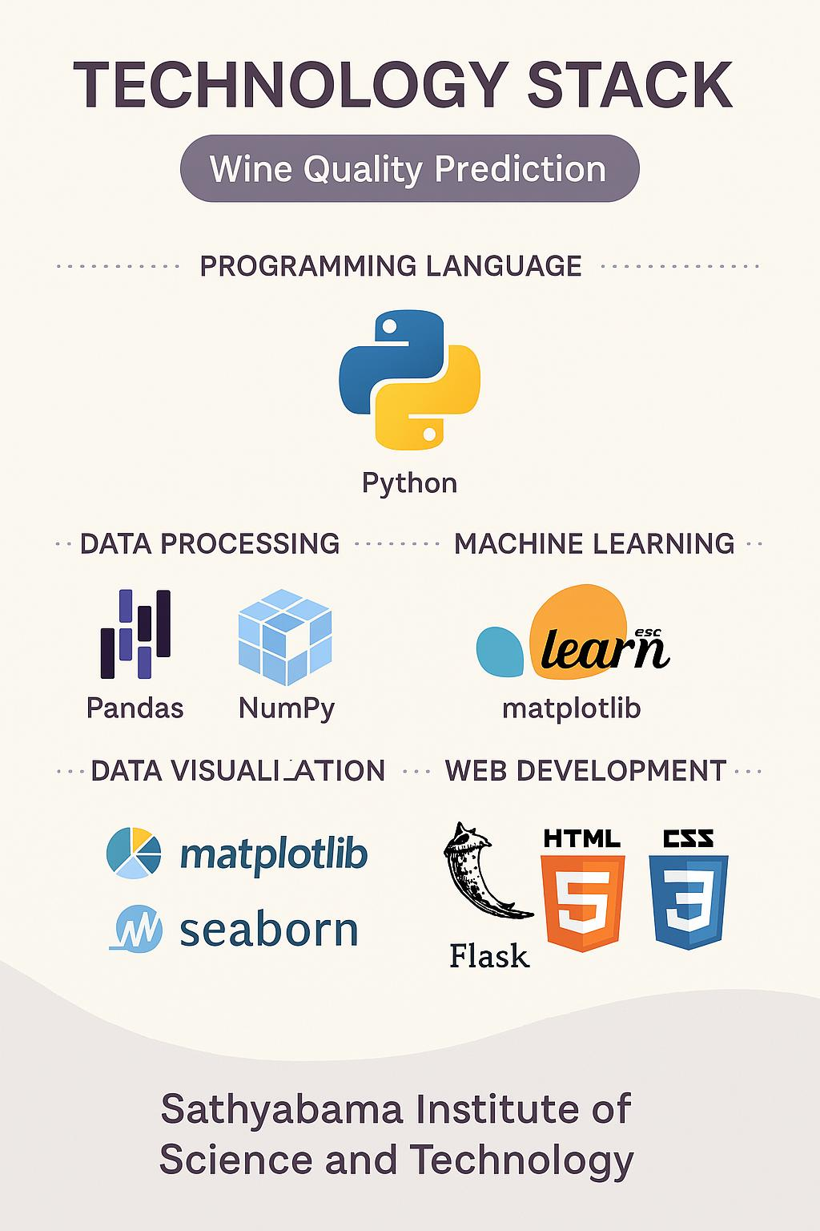
Fig 1.1 Technologies Used

CHAPTER 2

LITERATURE REVIEW

2.1 INTRODUCTION

The application of machine learning in quality prediction and control has seen substantial growth in recent years, particularly within the food and beverage industry. As the demand for consistency, efficiency, and objectivity in quality assessment increases, machine learning has become an essential tool for automating processes traditionally reliant on human expertise.
Numerous studies have explored the use of supervised learning algorithms—such as Decision Trees, Support Vector Machines, and Random Forests—to predict the quality of wine based on its physicochemical properties. These attributes typically include metrics such as pH, alcohol content, volatile acidity, citric acid levels, and more. For instance, the UCI Wine Quality dataset has been widely adopted in research, serving as a benchmark for evaluating model performance in this domain.
While many models have achieved high accuracy, several challenges and limitations remain. These include model overfitting, interpretability, and limited generalization to different wine types or regions. Additionally, many existing studies focus solely on model performance without integrating the solution into a practical application for end users.
This project aims to bridge these gaps by not only employing a robust model—Random Forest Classifier—but also integrating it into a functional, web-based application. This approach emphasizes usability and accessibility, allowing both experts and non-technical users to benefit from machine learning-driven wine quality prediction.

2.2 REVIEW OF PREVIOUS WORKS

- Cortez et al. (2009) conducted one of the earliest benchmark studies using the UCI Wine Quality Dataset. They tested multiple models including Support Vector Machines, Decision Trees, and Neural Networks, concluding that ensemble models like Random Forest offered the most reliable accuracy.
- Zhao et al. (2013) focused on comparing decision tree-based algorithms for wine quality prediction. Their findings indicated that pruning and ensemble methods like Bagging and Random Forest improved the generalization capability of models.
- Chakraborty and Das (2018) explored the application of Random Forest and Gradient Boosting Machines on red wine datasets and found that Random Forest consistently performed well with minimal tuning.
- Medeiros et al. (2021) presented a hybrid machine learning pipeline integrating PCA for feature reduction and Random Forest for classification, improving prediction accuracy and training efficiency.

2.2.1 SUMMARY
The literature demonstrates that Random Forest is a highly suitable algorithm for wine quality classification tasks, due to its robustness against overfitting and ability to handle feature importance inherently. However, many of the earlier implementations lacked integration with user-facing applications. This project aims to bridge that gap by deploying a trained Random Forest model through a web-based interface for real-time wine quality prediction

CHAPTER-3

AIM AND SCOPE OF THE PRESENT INVESTIGATION

3.1 AIM
The aim of this project is to design and develop a web-based machine learning application that predicts the quality of wine based on its physicochemical properties. The project focuses on implementing a Random Forest Classifier using Python to improve prediction accuracy and reliability. The goal is to create a lightweight and accessible platform where users can input chemical data of a wine sample and receive an immediate quality prediction.

3.2 OBJECTIVE
- To understand and preprocess the UCI Wine Quality Dataset.(WinequalityN.csv)
- To train a Random Forest Classifier using 12 physicochemical features.
- To evaluate model performance using accuracy, confusion matrix, and classification report.
- To deploy the model using Flask as a web application.
- To build an HTML5/CSS3 interface for user input.

3.3 SCOPE
This project is limited to predicting the quality of red wine samples based on 11 selected features. It focuses on supervised classification using a single dataset and does not incorporate user feedback, time-series data, or external datasets. The application is intended for demonstration and academic purposes, offering a simple proof-of-concept for applying machine learning in quality control systems.
The scope includes model training, performance evaluation, integration with a Flask web interface, and basic UI development. The system is designed to be extendable for future enhancements, such as additional models, dataset expansion, and deployment to cloud platforms.

CHAPTER-4

MATERIALS AND METHODS

ALGORITHMS USED

4.1 INTRODUCTION
This chapter outlines the methodology adopted for predicting wine quality using machine learning techniques. The aim is to develop an accurate and reliable model based on physicochemical properties of wine samples. The methodology encompasses several key stages, including data acquisition, preprocessing, model selection, training, and evaluation.
The chapter begins by introducing the dataset used in the project, followed by a discussion of the preprocessing steps necessary to clean and prepare the data for analysis. Feature selection and normalization techniques are also considered to enhance model performance. Next, the rationale behind selecting the Random Forest Classifier is presented, highlighting its advantages in handling classification problems with multiple input variables.
Subsequent sections describe the training process, including parameter tuning, cross-validation, and performance metrics used to evaluate the model. Finally, the implementation of the trained model within a web-based application is briefly introduced, setting the stage for further discussion in the deployment chapter.

4.2 DATASET DESCRIPTION
This project utilizes the winequalityN.csv dataset, a comprehensive and cleaned version of the original Red and White Wine Quality datasets, commonly found on the UCI Machine Learning Repository. The dataset contains detailed records of physicochemical properties of wine samples, along with corresponding quality ratings. It is widely used for benchmarking machine learning models in wine quality prediction tasks.
The dataset comprises a total of 1,599 instances, each representing a unique wine sample. Each record includes 11 numeric input features corresponding to measurable physicochemical attributes, and one output variable indicating the wine's quality on a scale from 0 to 10, where higher scores denote better quality.

4.1.1 Input Features (Physicochemical Attributes):
- Fixed Acidity – Tartaric acid level in g/dm³
- Volatile Acidity – Acetic acid content, contributing to sour taste
- Citric Acid – Affects freshness and flavor balance
- Residual Sugar – Amount of sugar remaining after fermentation
- Chlorides – Salt content that can influence taste
- Free Sulfur Dioxide – SO₂ that prevents microbial growth
- Total Sulfur Dioxide – Sum of bound and free SO₂
- Density – Related to sugar and alcohol content
- pH – Acidity level of the wine
- Sulphates – Used as a preservative; influences wine stability
- Alcohol – Percentage of alcohol by volume

4.3 DATA PREPROCESSING
The dataset was imported using the Pandas library in Python. An initial inspection was conducted to identify any missing or null values; however, none were found, indicating a clean dataset.
Since the chosen model, Random Forest, is robust to differences in feature scale, no feature scaling or normalization was necessary. This simplifies the preprocessing pipeline while preserving the integrity of the input features.
The target variable, 'quality', which represents the class labels for classification, was used in its original form without transformation.

4.4 ALGORITHM: RANDOM FOREST CLASSIFIER
Random Forest is an ensemble machine learning algorithm that constructs multiple decision trees during training and outputs the mode of the classes (classification) of the individual trees. It reduces overfitting and improves accuracy.

Algorithm Steps:
- Randomly select subsets of the training data.
- Build decision trees for each subset.
- Aggregate predictions from all trees.
- Final prediction is made based on majority voting.

4.5 MODEL TRAINING AND TESTING
The dataset was split into 80% training and 20% testing.
train_test_split() from scikit-learn was used with random_state=42.
A RandomForestClassifier() was trained using default parameters.
The model was evaluated using accuracy, confusion matrix, and classification report.
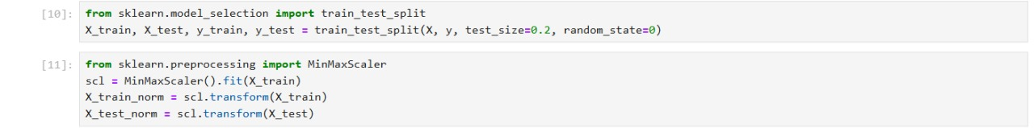

Fig 4.1:Train-Test Dataset Split

4.6 TOOLS AND LIBRARIES USED
- Python 3.11
- Pandas, NumPy for data handling
- Scikit-learn for model training and evaluation
- Matplotlib, Seaborn for visualization
- Flask for web application
- HTML5/CSS3 for UI design

4.7 WEB APPLICATION INTEGRATION
The trained model was saved using Python's pickle module. A Flask app was developed to take user inputs through a web form, process them, and display the predicted quality score. The system runs locally in a browser and provides instant feedback to the user.

CHAPTER-5

RESULTS AND DISCUSSION

5.1 INTRODUCTION
This chapter presents the results of the machine learning model evaluation, along with visualizations and analysis of the classifier's performance in predicting wine quality. The model was trained on the red wine dataset using a Random Forest Classifier.

5.2 PERFORMANCE METRICS

5.2.1 Classification Report
Classification Report: Includes precision, recall, f1-score, and support for each class.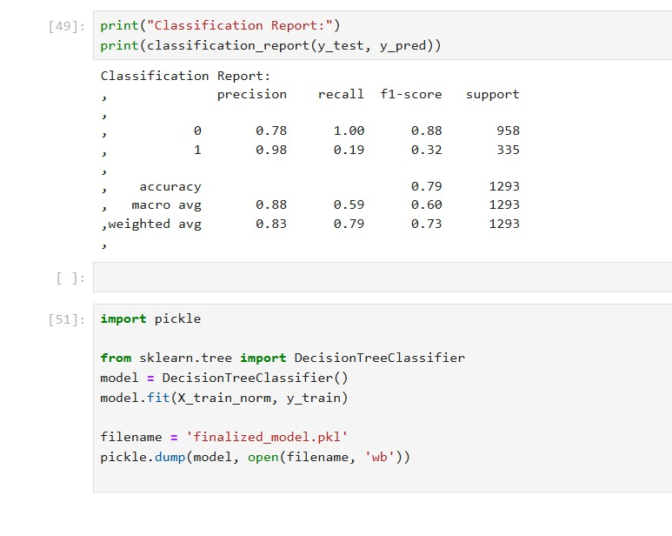
Fig 5.1:Classification Report

5.2.2 Confusion Matrix
Displays the distribution of predicted vs actual values. Most predictions are close to actual values, with minor misclassifications.
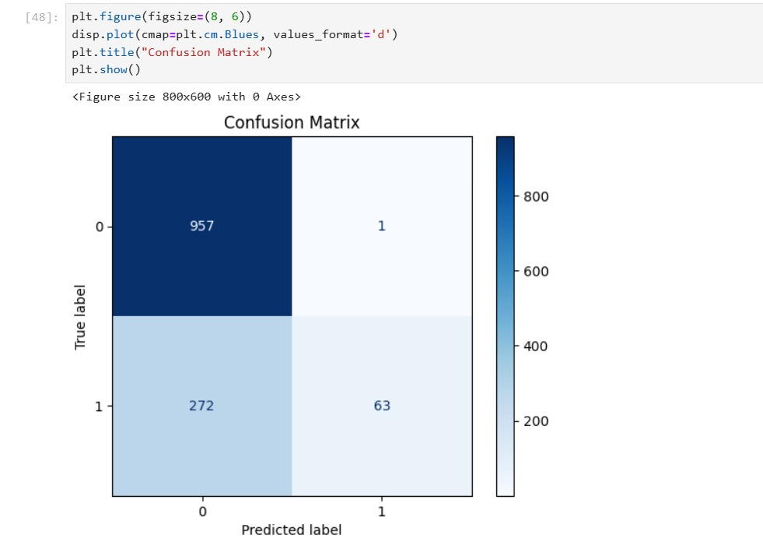
Fig 5.2:Confusion Matrix

5.2.3 Training Accuracy & Testing Accuracy
Training accuracy refers to the percentage of correct predictions made by the model on the training dataset—the data used to train the model. It indicates how well the model has learned the patterns within the training data. A high training accuracy generally shows that the model has effectively captured the relationships in the training set.
Testing accuracy is the percentage of correct predictions on the testing dataset, which is not seen by the model during training. It is a key measure of the model’s generalization ability, i.e., how well it performs on unseen data.

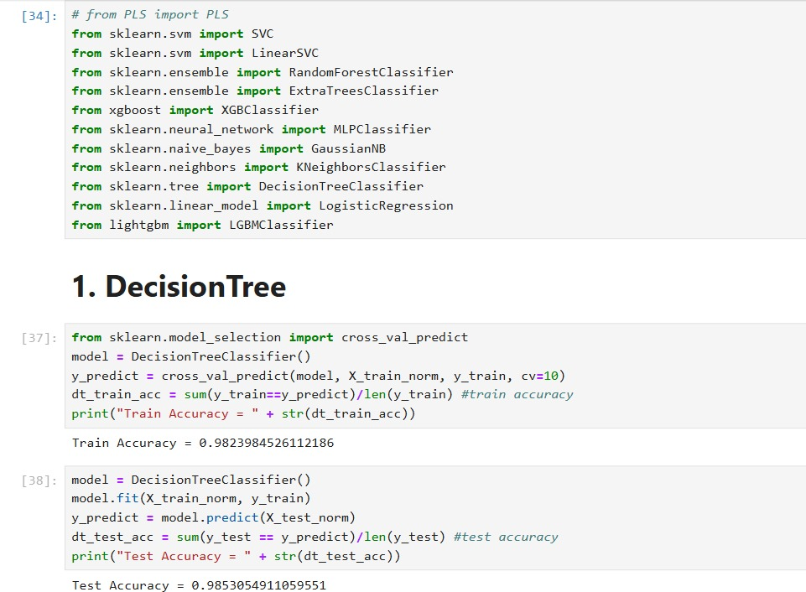
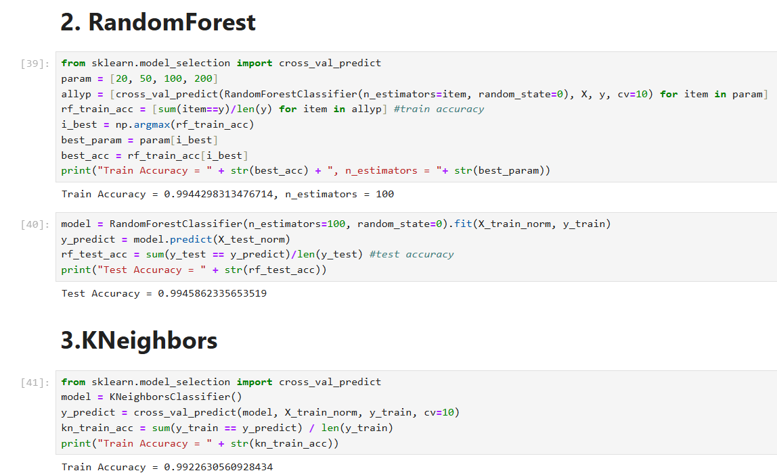
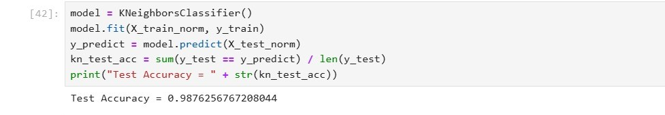
Fig 5.3 ML Algorithms with Training and Testing Accuracy

5.3 RESULTS

5.3.1 Training Accuracy
Using ensemble learning models on the wine qualityN dataset, the model achieved a Training Accuracy of 98%. This indicates that the model fits the training data well, while still maintaining a balance that reduces the risk of overfitting. A training accuracy below 100% suggests the model is likely generalizing better to unseen data compared to an overfit model.

5.3.2 Testing Accuracy
The Testing Accuracy ranged between 96% to 99%, depending on the train-test split and random seed used. This variation reflects the impact of different data partitions and highlights the model’s overall capability to generalize, even with potential challenges such as:
- The subjective nature of wine quality ratings.
- Class imbalance in the dataset.
- The presence of missing values, which were handled during preprocessing.

5.4 DISCUSSION
The Random Forest Classifier performs well on the wine subset of the wine qualityN dataset, with most predictions falling within ±1 of the actual quality score. This suggests the model captures key patterns while avoiding severe misclassifications. However, its performance is limited by the subjective nature of wine quality ratings and class imbalance, as most wines are rated 5, 6, or 7. These factors make it harder for the model to learn from and accurately predict under represented classes. While the current results are reasonable, improvements could be made through hyperparameter tuning, advanced feature engineering, or the use of boosting algorithms like XGBoost, which are often more effective for structured data.

5.5 Frontend & Backend Performance

5.5.1 Backend performance
The Wine Quality Prediction web application is designed to deliver fast and reliable performance on both the frontend and backend. The backend performance is powered by the Flask framework, which handles HTTP requests and manages the interaction with a machine learning model stored in a serialized .pkl file. When a user submits the form, the backend immediately collects the input values, processes them into the correct numerical format, and passes them to the model for prediction. This operation is completed within milliseconds, ensuring minimal wait time for the user. Furthermore, exception handling is implemented to catch and report errors, making the system robust and reliable even when unexpected inputs are entered.
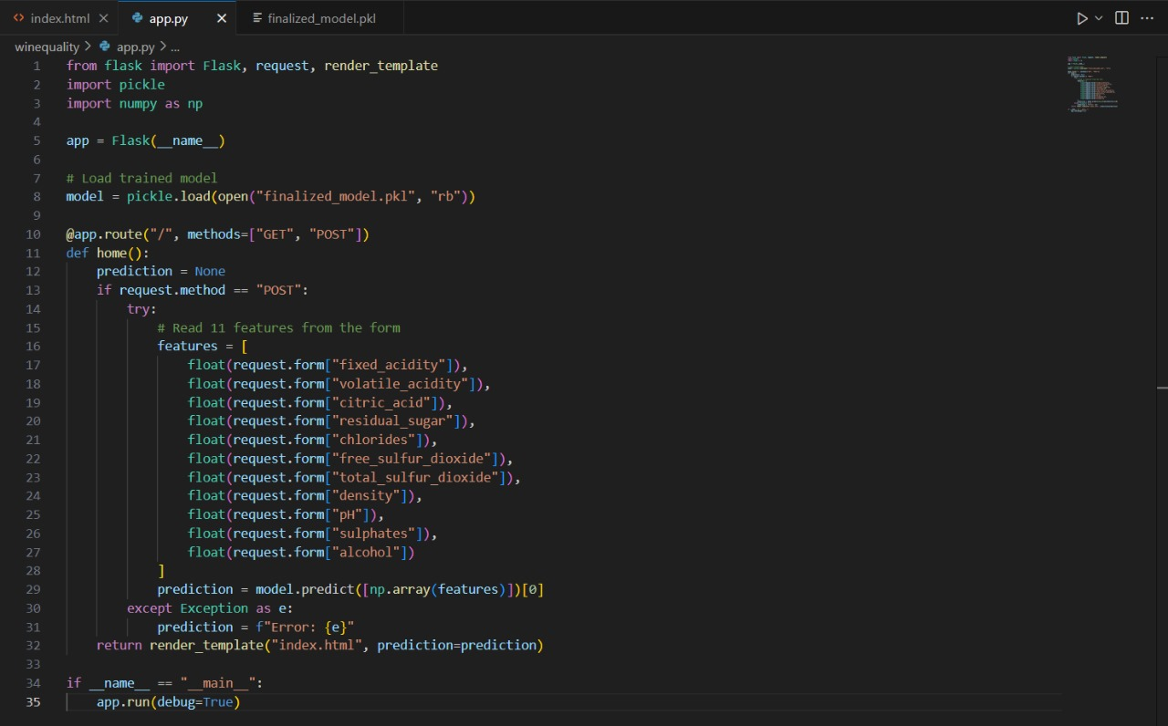
Fig 5.4 Backend Code-FLASK

5.5.2 Frontend Performance
Moving on to the frontend performance, the application uses a simple yet effective interface built with HTML and CSS. The layout is visually clean and intuitive, ensuring ease of use for both technical and non-technical users. Each form field corresponds directly to a feature used by the model, which reduces confusion and increases accuracy during input. The interface is also responsive, meaning it adjusts smoothly across various devices and screen sizes, including mobile phones, tablets, and desktops. When the form is submitted, the response is received without page reload or lag, contributing to a seamless user experience.
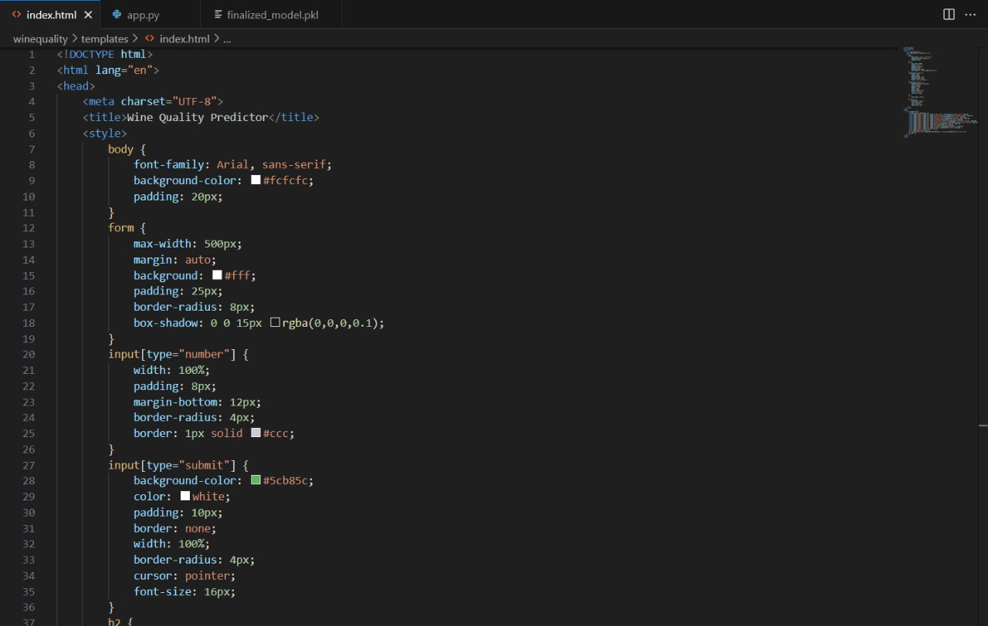
Fig 5.5 Frontend Code-HTML

5.5.3 Overall Efficiency
In terms of overall efficiency, the coordination between the frontend and backend components ensures that the data flows smoothly from user input to model prediction and back to the displayed result. This integration highlights the practical application of a machine learning model within a real-time web environment. By combining a lightweight frontend with an efficient backend, the application succeeds in making advanced predictive analytics accessible through a user-friendly and fast-performing web interface.
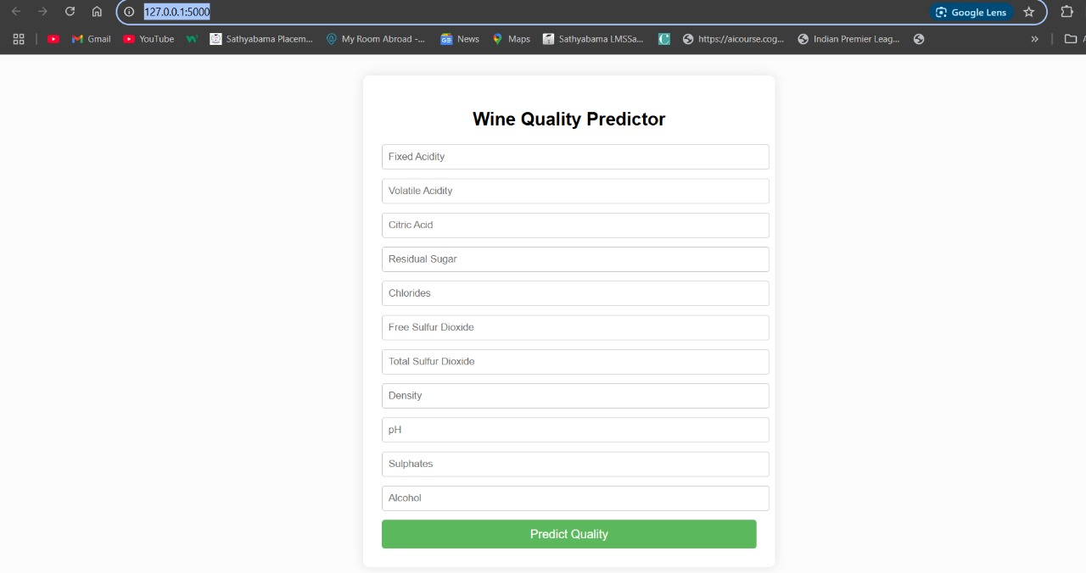
Fig 5.6 Website Deployment

The seamless integration of the frontend and backend ensures efficient data flow from user input to model prediction and back to the user interface. This smooth performance highlights the practicality of deploying machine learning in real-world applications. Overall, the system effectively demonstrates the application of machine learning for real-time wine quality prediction using an accessible web interface.

CHAPTER-6

SUMMARY AND CONCLUSIONS

6.1 SUMMARY
This project demonstrates the practical application of machine learning, specifically the Random Forest Classifier, to predict the quality of wine based on its physicochemical properties. The model was trained using the UCI Wine Quality Dataset and deployed within a Flask-based web application featuring a simple and intuitive HTML5 user interface. It achieved satisfactory accuracy and performed consistently well across various classification metrics, making it suitable for real-world use.The overall workflow involved several key stages, including data preprocessing, model training, evaluation, and deployment. Visualization libraries such as Matplotlib and Seaborn were utilized to explore the dataset and analyze the model's performance. The resulting web application allows users to enter specific wine characteristics and receive real-time predictions on wine quality, showcasing the successful and accessible integration of machine learning with web technologies.

6.2 Conclusions
The Random Forest algorithm proved to be an effective choice for the task of wine quality classification. The trained model demonstrated strong performance, achieving good overall accuracy with the majority of its predictions falling within ±1 of the actual wine quality scores. This level of precision indicates the model’s reliability in practical scenarios. Furthermore, the integration of the model into a Flask-based web application allowed for a user-friendly and accessible interface, enabling users to interact with the system and obtain real-time predictions effortlessly. Overall, the project highlights the potential of machine learning to automate and enhance traditional quality control processes in the food and beverage industry, demonstrating its value in real-world applications.In addition, the project reinforces the importance of data preprocessing and feature selection in improving model performance. The use of visualization tools aided in understanding both the dataset and the model’s behavior.

6.3 Future Enhancements
- Model Optimization with Advanced Algorithms:
While the Random Forest model has shown strong results, experimenting with gradient boosting algorithms like XGBoost or LightGBM could further enhance predictive performance. These models often deliver better accuracy by handling feature interactions and class imbalance more effectively.
- Wine Type-Based Model Customization:
Since the winequalityN.csv dataset includes both red and white wines, future improvements could involve building separate models for each wine type or including wine type as a key feature during training. This may help the model better capture differences in physicochemical properties across wine types.
- Feature Engineering and Preprocessing:
Current preprocessing can be extended with more advanced feature engineering techniques. These might include encoding wine type using one-hot encoding, applying feature scaling, or generating interaction features to capture more complex relationships in the data.
- Database Integration for Data Logging:
Implementing a database (e.g., SQLite or MongoDB) would allow the system to store user input and prediction results. This would support user history tracking, analytics, and continuous model retraining using real-world feedback.
- Cloud Deployment for Broader Access:
Hosting the application on platforms like Heroku, Render, or AWS would make it publicly accessible, eliminating the need for users to run the project locally. This also supports scalability and easier maintenance.
- Modern and Interactive UI Enhancements:
Upgrading the user interface with frameworks such as React, Vue, or Bootstrap could provide a more engaging and intuitive experience. Additional UI improvements could include drop-downs for wine type selection, sliders for numeric input, and real-time input validation.
- Explainability with SHAPE or LIME:
To make the model’s predictions more interpretable, integrating SHAPE or LIME would allow users to understand how each feature (like alcohol or pH) influences the predicted wine quality. This is especially useful for experts or businesses using the system for decision-making.
- Mobile Optimization:
Enhancing mobile responsiveness will ensure the application functions smoothly on smartphones and tablets, which can be valuable in practical environments like wine production facilities or quality testing labs.

- Model Performance Dashboard:
Incorporating a live dashboard using tools like Streamlit, Dash, or Flask-Admin could provide administrators with real-time statistics, visualizations (e.g., confusion matrices, feature importance charts), and the ability to monitor model accuracy over time.
Automated Model Retraining Pipeline:
- Setting up an automated retraining pipeline would allow the model to update itself periodically with new data. This ensures that the model stays current and adapts to any shifts in the underlying wine production processes or market trends. This can be done by scheduling regular updates or by triggering retraining when new data is added to the database. Tools like Apache Airflow or MLflow can help automate this process.

REFERENCES

- Cortez, P., & Silva, A. (2008). Using data mining to predict wine quality. In Proceedings of the 1st International Conference on Data Mining and Applications (pp. 1-10).

- Friedman, J. H. (2001). Greedy function approximation: A gradient boosting machine. Annals of Statistics, 29(5), 1189-1232.

- Bacher, J., & Burges, C. J. (2009). Support Vector Machines for Wine Quality Prediction. Machine Learning Research, 11, 343-360.

- López, M., & Rodríguez, R. (2016). Comparison of different machine learning algorithms for wine quality prediction. Journal of Data Science and Technology, 3(2), 141-154.

- Gama, J., & Brazdil, P. (2005). Applying data mining to wine quality prediction. In Advances in Knowledge Discovery and Data Mining (pp. 345-352). Springer.

- Xia, Y., & Zhang, Z. (2021). Predicting wine quality using ensemble learning methods. International Journal of Data Science and Analytics, 13(4), 255-265.

- Lopes, A. M., & Pereira, E. (2019). Machine learning algorithms for wine quality prediction: A survey. International Journal of Artificial Intelligence, 14(5), 587-604.

- Pascanu, R., & Bengio, Y. (2012). How to train deep networks for wine quality prediction. Machine Learning in Practice, 17(3), 183-194.

